**Deploying ASP .Net Core + SQL on Azure Paas Service**

**IMPORTING THE DATABASE ON AZURE SQL SERVER**

* Using Data tier Application, the database is exported with schemas and all tables from SQL Server Management Studio to a storage account on Azure as a BACPAC file.
* After the BACPAC file was uploaded, the Azure SQL server was created and the database was imported by selecting the BACPAC file in the storage account.
* The database is now imported to Azure SQL Server.

**DEPLOYING .NET CORE WEB API ON AZURE APP SERVICE**

Step 1: Go to your project and click on Publish. Select azure and click on next

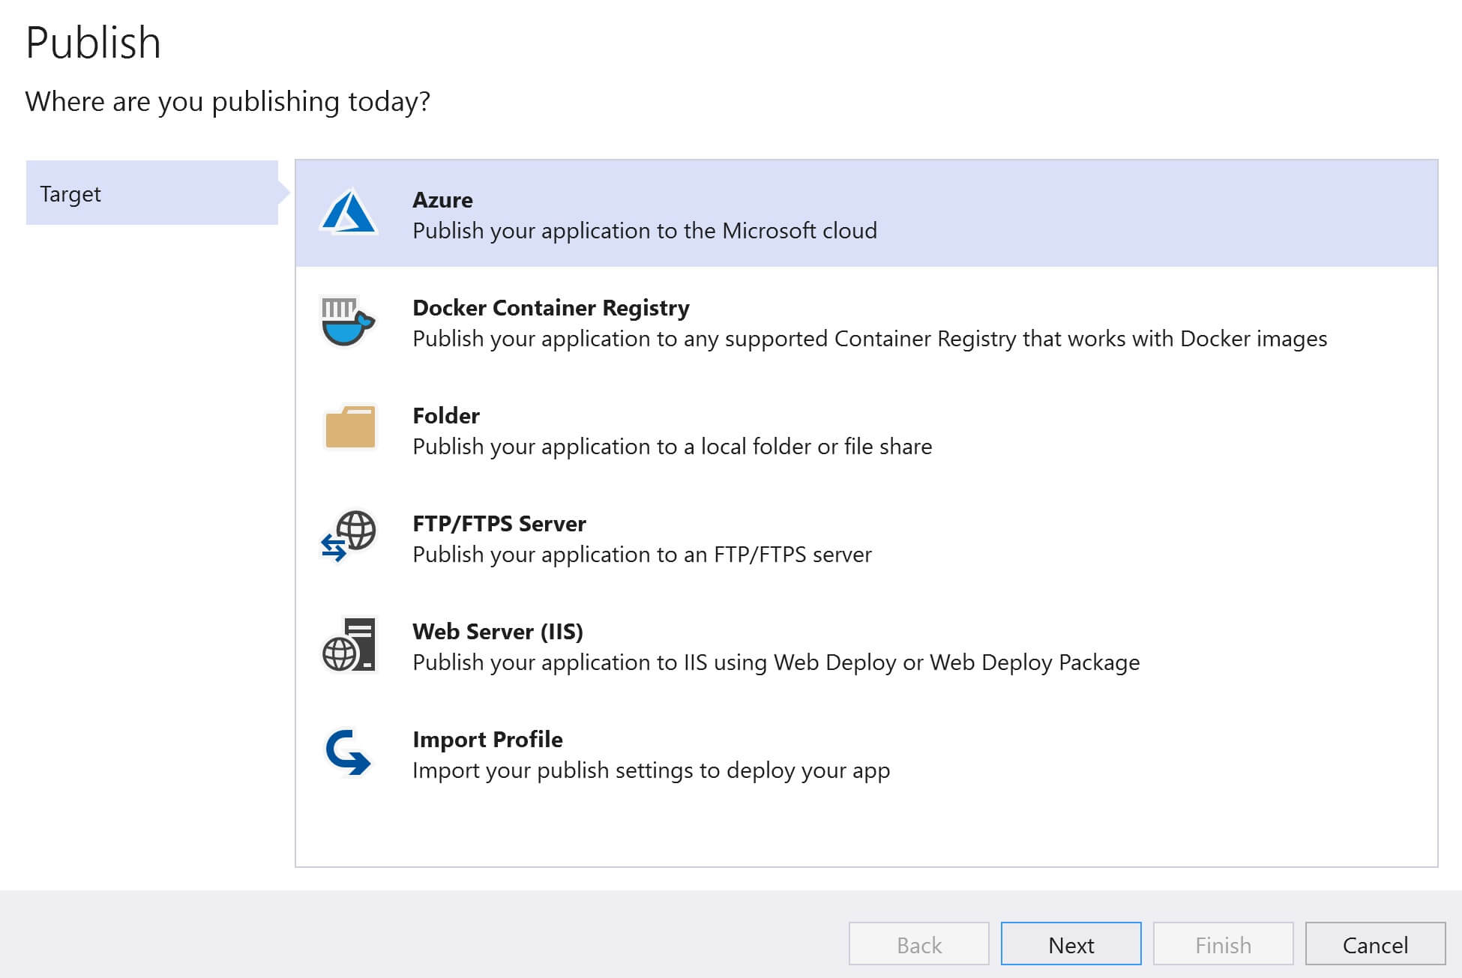

Step 2: Select your desired host application. And click on next

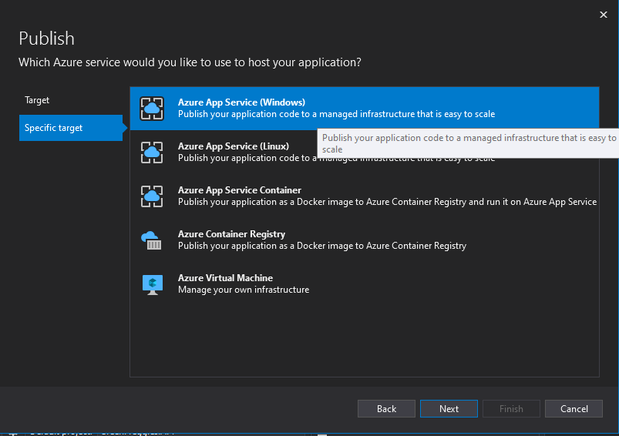

Step 3: Select your Subscription type and then click on the add button



Step 4: Provide a name for the App Service. This is the name that will be used to access the web application. CropDeal the name I used, so to access the application I use the following URL in the browser.

Step 5: https://CropDeal.AzureWebSites.net

Step 6: Select your subscription and resource group

Step7: Finally hosting plan. We want to use a free hosting plan. Click on the new link.

Step 8: Provide a name, location and the size for the Hosting Plan. It is the size that determines what you pay and what features you get. I selected the free pricing tier.

Step 9: Remember to host a web application in Azure we need App Service and an App Service Plan. We discussed App Service and App Service Plan, including how to create them in the Azure portal, in our previous videos in this series.

Step 10: Right now, we are creating them (App Service and App Service Plan) from within visual studio instead of going through the azure portal.

Step 11: Click OK and the Finish.